**3.7.3 External requirements**

External requirements include all that come from factors external to the system and its development process, policies and procedures of customer and related organizations.

**3.7.3.1 Safety / Security requirements**

Before providing bookmark services to users, the system must first require agreement to terms, conditions, the use of personal information and provide notification of the handling policy. In addition, if information is provided externally, the user's agreement must precede in advance. In the case of this system, personal information and bookmarks of users should not be leaked, and it is important to pay attention to database management so that users can use the system with confidence.

**3.7.3.2 Regulatory requirements**

In order for users to use the bookmark function, they must be logged in to i-campus to check their personal identities, and access videos only for the subjects they are taking. After these identities are confirmed, bookmarks provided by professors can be accessed, and personal bookmarks can be added, modified, and deleted.

**3.8 Organizing the Specific requirements**

In this part, the system model can be described specifically using Unified Modeling Language (UML) and tabular-based graphical notation. System models can correlate the relationships between systems, subsystems, components, and their surroundings and demonstrate more specific requirements.

**3.8.1 Context Model**

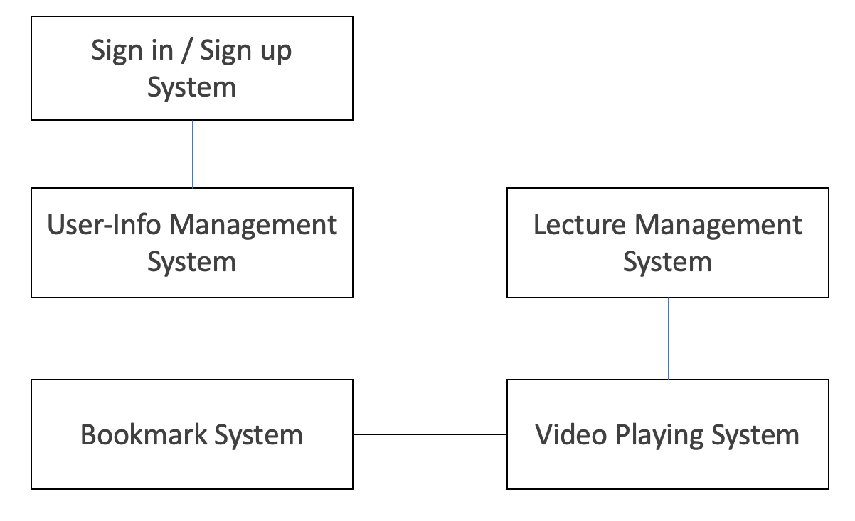

**3.8.2 Process Model**

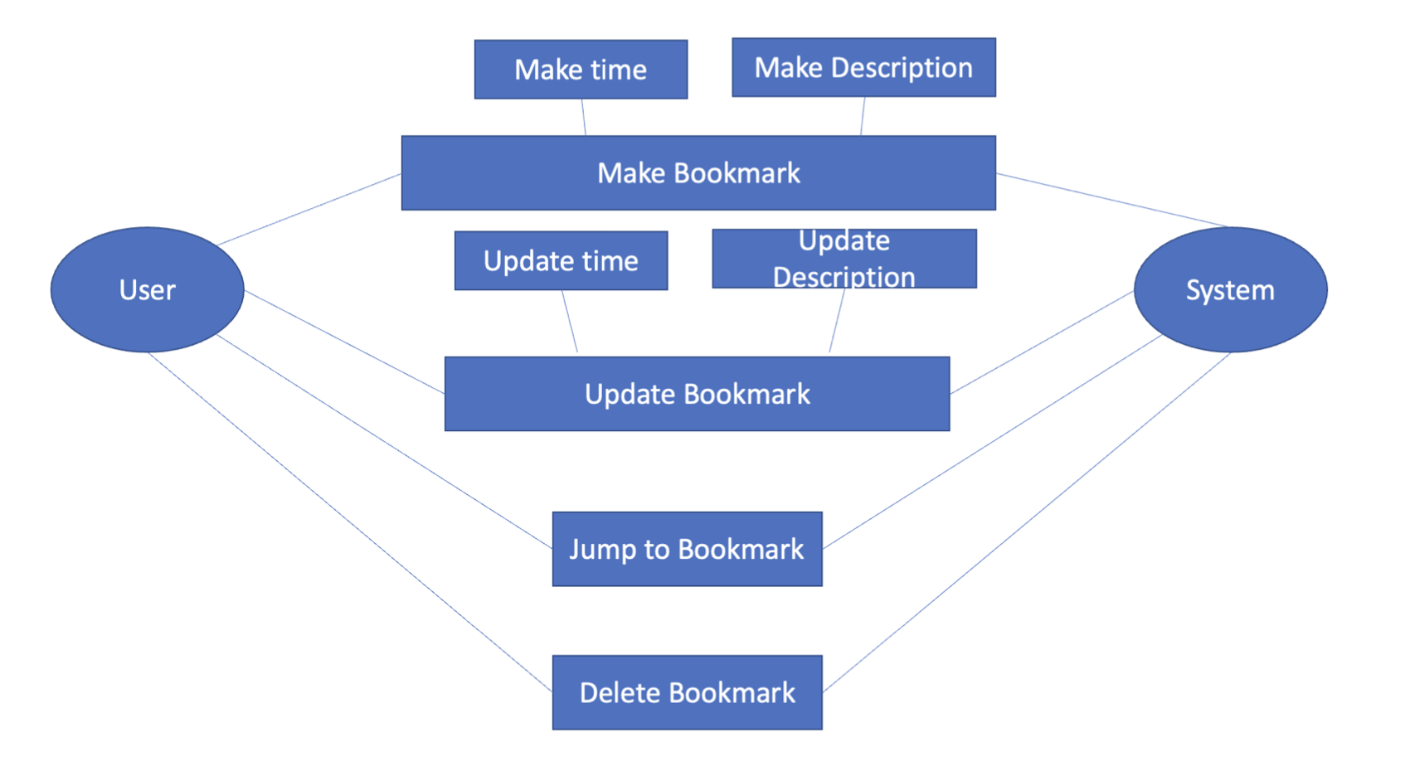

**3.8.3 Interaction Model**

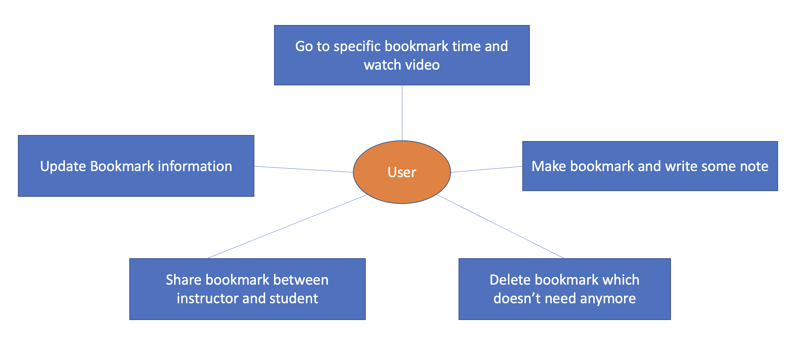

**3.8.4 Behavior Model**

**3.8.4.1 Data Flow Diagram**

See 3.2.4. Data Flow Diagram

**3.8.4.2 Sequence Diagram**

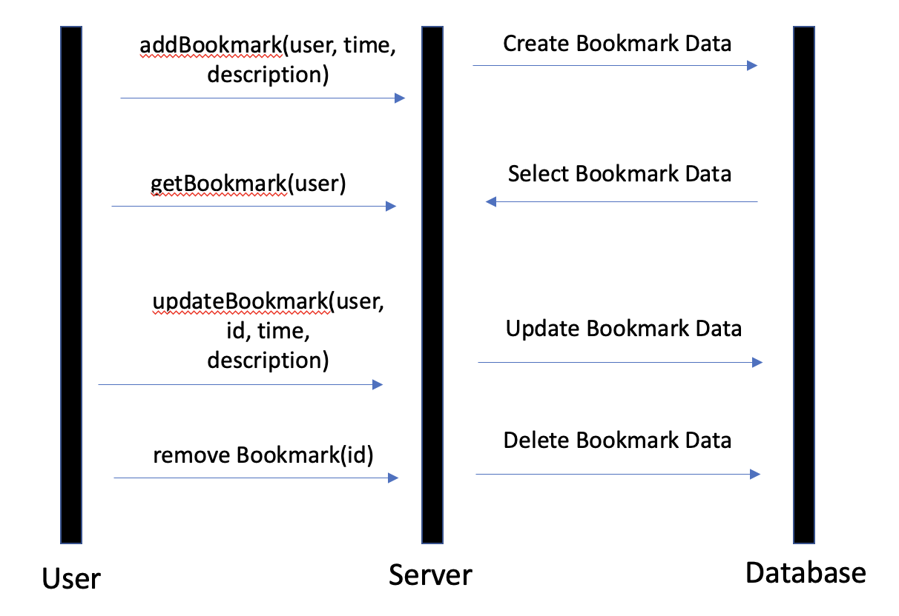

**3.9 System Architecture**

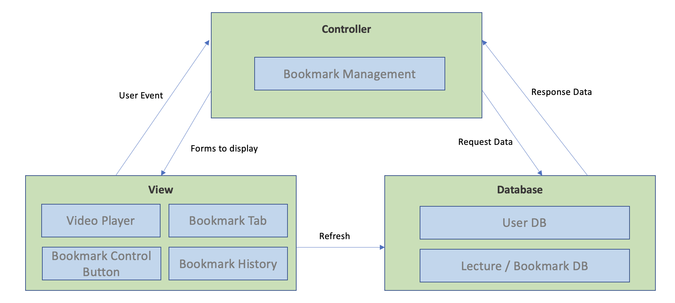

**3.10 System Evolution**

This section describes the basic assumptions and rules underlying the system and anticipates of all changes due to hardware evolution, software evolution, and changes in user requirements. This section is useful for system designers as it can help them avoid choosing designs that may constrain future changes to the system.

**3.10.1 Limitation and Assumption**

We assume that users can access them all through desktops, laptops, and smartphones. So, we need to deal with both connections through web browsers and mobile applications. Therefore, we understand that we need to build functions and implement system architecture that are compatible with both these web and mobile applications.

**3.10.2 Evolutions of Hardware and Change of User Requirements**

It aims to support the functionality for use on laptops, desktops, and smartphones that are currently mainstream. It also predicts that Internet of Things technology and wearable devices will evolve in the future and that there will be areas to cope with as these hardware advances. In addition, we will design programs so that they can easily change so that additional users' requirements for bookmark functions can change fluidly accordingly.

**4. Supporting Information**

**4.1 Software Requirements Specification**

This software requirements specification was written in accordance with the IEEE Recommendation (IEEE Recommended Practice for Software Requirements Specifications, IEEE-Std-830).

**4.2 Document History**

| **Date** | **Version** | **Description** | **Writer** |
| --- | --- | --- | --- |
| 2021/04/20 | 0.1 | Overall Style and form of documents | Jiseon Lee |
| 2021/04/20 | 1.0 | Addition of 2.2, 2.3, 2.4 | Chihyeon Lee |
| 2021/04/20 | 1.1 | Addition of 3.3, 3.4, 3.5, 3.6 | Dongjun Lee |
| 2021/04/22 | 1.2 | Addition of 1.1, 1.2, 1.3 | Jiseon Lee |
| 2021/04/22 | 1.3 | Addition of 3.7, 3.8, 3.9, 3.10, 4.1 | Seungwoo Kim |
| 2021/04/23 | 1.4 | Addition of 2.5, 3.1, 3.2, 3.3 | Deokjae Kang |